TITLE: EXPERIMENT TO VERIFY NEWTON’S LAW OF COOLING OF A LIQUID.
AIM : To verify Newton’s law of cooling of a liquid – water
APPARATUS: Calorimeter with stirrer, thermometer (0⁰-100⁰), gas burner, retort stand.
DIAGRAM:

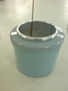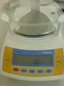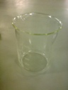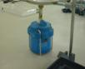
Calorimeter with stirrer Electric balance Glass beaker Gas burner with retort stand

THEORY:
A hot liquid loses heat to the surrounding when it is left to cool over a period of time. A graph of temperature against time of heat loss gives a curve known as cooling curve with a negative gradient.
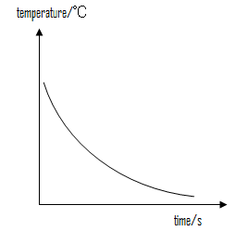

Newton’s law of cooling states that the rate at which heat is lost from a hot body as it cool down is directly proportional to the temperature difference between the hot body and the surrounding.
Mathematically
$\frac{dθ}{dt}$ $\frac{Heat}{time}∝temperature difference$
$\frac{θ}{t}∝(θ-θo)$
$\frac{dθ}{t}=k(θ-θo)$

$θ-θo$

Where θ is the temperature of the body
θ is the temperature of the surrounding
k is a constant which is the slope
A graph of $\frac{dθ}{dt}$ against (θ-θ₀) is a straight line

PROCEDURE:
A calorimeter was placed on a bad conductor and placed near open window. Room temperature is measured using a thermometer and recorded as θs₀ ⁰c. Water was heated in a beaker to 90⁰c using the gas burner, retort stand. The calorimeter was filled with about more than half full of the heated water and covered with the thermometer and stirrer in place. Keeping the cooling liquid well stirred all the time the temperature of the liquid was recorded at 1minute (60 seconds) interval until the temperature dropped to 35 ⁰c. The temperature of the surroundings was recorded after the experiment and recorded as θs₁⁰c. The mean room temperature was calculated for and recorded as θs₀⁰c.
OBSERVATION:
Temperature of surrounding before experiment = 31⁰c
Temperature of surrounding after experiment =29⁰c
Average temperature of the surroundings= 30⁰c
The results of the experiment were tabulated. The plotted values were tabulated as follows;

PLOTTED VALUES
Time (t) |  |  | Temperature  (⁰c)
seconds |  | minute | Temperature  (⁰c)
0 |  | 0 | 90
300 |  | 5 | 80
600 |  | 10 | 70
900 |  | 15 | 62
1200 |  | 20 | 58
1500 |  | 25 | 53
1800 |  | 30 | 49
2100 |  | 35 | 46
2400 |  | 40 | 43
2700 | 45 |  | 41
3000 | 50 |  | 38
3300 | 55 |  | 35

CALCULATION:
A graph of temperature(⁰c) against time(s).

Slope at 85⁰c $\frac{90-80}{0-5}$ = -2⁰c
Slope at 75⁰c $\frac{80-70}{5-10}$ = -2⁰c
Slope (⁰c/min) | θ-θ₀ (⁰c)
2 | 56
2 | 46
1.42 | 36
0.83 | 26
0.59 | 16
0.56 | 6
Slope at 65⁰c $\frac{70-60}{10-17}$ = -1.42⁰c/min
Slope at 55⁰c $\frac{60-50}{17-29}$ = -0.83⁰c/min
Slope at 45⁰c $\frac{50-40}{29-46}$ =-0.59⁰c/min
Slope at 35⁰c $\frac{40-35}{46-55}$ =-0.56⁰c/min

θ – θ₀ = (Temperature at slope – Mean temperature of surroundings)

A GRAPH OF SLOPE (⁰c/min ) AGAINST TEMPERATURE (⁰c)

